BEC Lab CA
Group Project Report: BJT AS DIGITAL LOGIC GATES

Course / Subject Name :
Basic Electrical Circuits Laboratory
Topic Title :
Design and Analysis of BJT as Universal logic gates

Class : SY – EXTC Batch : A3
- Team Members -
- Name : Nived Shenoy
Roll No. : 16010324048
- Name : Dhairya Shah
Roll No. : 16010324044
- Name : Hrishikesh Shah
Roll No. : 16010324046

Date of Submission : 03rd October 2025 (Friday)

Abstract :
This report presents the design and simulation of logic gates using Bipolar Junction Transistors (BJTs) configured as digital switches. The study focuses on the realization of NAND, NOR, and AND gates using NPN transistors in saturation and cutoff modes. Simulations were performed in LTspice to analyze voltage transfer characteristics and verify truth tables. Proper biasing resistors were used to ensure reliable switching at 5 V logic levels. The simulated output waveforms and measured voltage levels confirm the expected logical behavior of each gate. The experiment demonstrates that BJTs can be effectively used to construct universal logic gates, forming the foundation of transistor–transistor logic (TTL) circuits and modern digital systems.

Introduction :

Logic gates are the fundamental building blocks of all digital systems. Universal logic gates such as NAND and NOR are capable of realizing any Boolean function, making them crucial for implementing combinational and sequential circuits. In this experiment, Bipolar Junction Transistors (BJTs) are used to implement NAND, NOR, and AND gates at the transistor level. BJTs can operate as electronic switches, functioning in cutoff and saturation regions to represent binary states ‘0’ and ‘1’. By interconnecting transistors in specific configurations, logical operations can be realized directly in hardware. The NAND gate is achieved by connecting transistors in series, while the NOR gate is obtained through parallel connections. Furthermore, an AND gate can be derived from a NAND gate by adding a single inverter stage. The purpose of this experiment is to design, simulate, and verify these transistor-level logic gates using LTspice to understand the underlying principles of transistor logic and its role in digital circuit design.

Theoretical Analysis and Design

A BJT can act as a switch depending on its biasing conditions. When the base-emitter junction is forward biased, the transistor enters saturation, representing a logic LOW (0) at the output. When the base is at 0 V, the transistor is in cutoff, and the collector is pulled HIGH (1) through a pull-up resistor. These two states allow a BJT to behave as a binary switch, making it suitable for digital logic implementation.
In a BJT NAND gate, two NPN transistors are connected in series between the output node and ground. The output is connected to +5 V through a 1 kΩ pull-up resistor. When both inputs are HIGH, both transistors saturate, creating a direct path from the output to ground and pulling the output LOW. For any other input condition, at least one transistor remains OFF, keeping the output HIGH through the pull-up resistor. This yields the Boolean expression Y=A⋅B‾Y = \overline{A \cdot B}Y=A⋅B.
In a BJT NOR gate, the two transistors are connected in parallel between the output node and ground. When either input is HIGH, the corresponding transistor conducts, pulling the output LOW. Only when both inputs are LOW do both transistors remain OFF, allowing the output to remain HIGH. This implements the Boolean function Y=A+B‾Y = \overline{A + B}Y=A+B​.
Finally, an AND gate can be constructed by connecting a NAND gate followed by an inverter (single transistor inverter stage). The NAND output serves as the input to the inverter transistor, producing a final output of Y=A⋅B‾‾=A⋅BY = \overline{\overline{A \cdot B}} = A \cdot BY=A⋅B=A⋅B.
Resistor values were chosen to ensure proper transistor operation. Each transistor base is driven through a 10 kΩ resistor, and the collector load (pull-up resistor) is set to 1 kΩ. The circuit operates from a 5 V DC supply.

LT Spice Experiment and Results :

The circuits were designed and simulated using LTspice. Two PULSE voltage sources were used as logic inputs (A and B), generating square waves alternating between 0 V and 5 V. Each simulation was run for 100 microseconds using the transient analysis directive .tran 0 100u. The transistor model used was 2N2222. Measurement commands were added to extract average output voltages during each input condition:
.meas TRAN OUT00 AVG V(Out) FROM=10u TO=20u
.meas TRAN OUT01 AVG V(Out) FROM=30u TO=40u
.meas TRAN OUT10 AVG V(Out) FROM=50u TO=60u
.meas TRAN OUT11 AVG V(Out) FROM=80u TO=90u
The simulation results matched the expected logic behavior. For the NAND gate, the output remained HIGH (~4.9–5.0 V) for all input combinations except when both A and B were HIGH, where it dropped to approximately 0.1 V, representing a logical 0. For the NOR gate, the output was HIGH only when both inputs were LOW, and LOW for all other cases. The AND gate, implemented by cascading a NAND gate with a transistor inverter, produced HIGH output only when both inputs were HIGH.
The measured output voltages were tabulated and compared with theoretical values. The truth tables from the LTspice simulation logs were as follows:

AND Gate:
A | B | Output
0 | 0 | 1
0 | 1 | 1
1 | 0 | 1
1 | 1 | 0

NAND GATE:
A | B | Output
0 | 0 | 0
0 | 1 | 0
1 | 0 | 0
1 | 1 | 1

NOR GATE:
A B Output
0 0 1
0 1 0
1 0 0
1 1 0

Discussion and Analysis

The LTspice simulation results closely matched theoretical expectations. The NAND and NOR configurations behaved as universal logic gates, confirming that BJTs can successfully emulate logic-level switching. The measured output voltages exhibited minor deviations from ideal 0 V or 5 V levels due to the transistor saturation voltage (approximately 0.1–0.2 V). Proper selection of base and collector resistors ensured sufficient base current for full saturation and fast switching.
The NAND gate, with BJTs in series, demonstrated clear inversion of the AND logic function, while the NOR gate, with BJTs in parallel, inverted the OR operation. The AND gate, implemented through a NAND-inverter cascade, functioned as expected, producing a HIGH output only when both inputs were HIGH. These results validate the principle that NAND and NOR gates are universal, capable of constructing any digital circuit.
This experiment provides valuable insight into transistor-level logic operation, which forms the basis for transistor–transistor logic (TTL) and early integrated circuit designs. It also reinforces the importance of transistor biasing and load-line considerations in digital switching circuits
Final Output
AND Gate using BJT
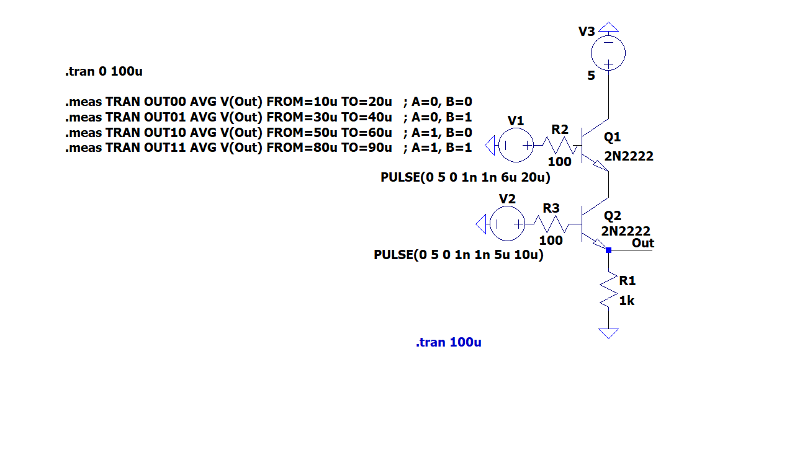
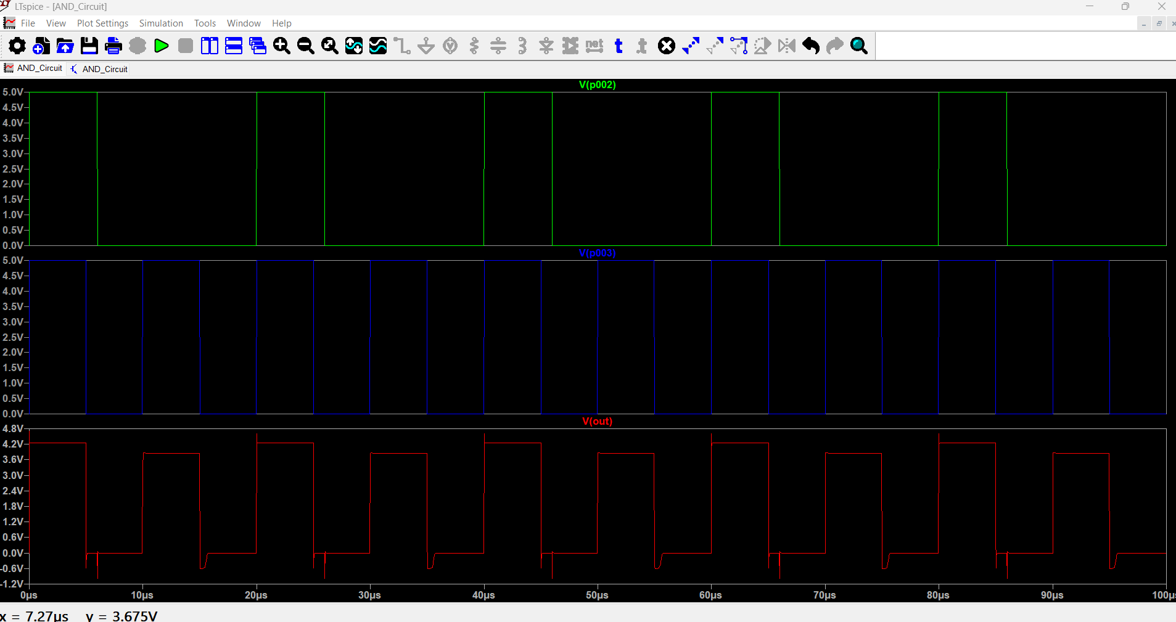

NAND NNNN

NNNN
NAND 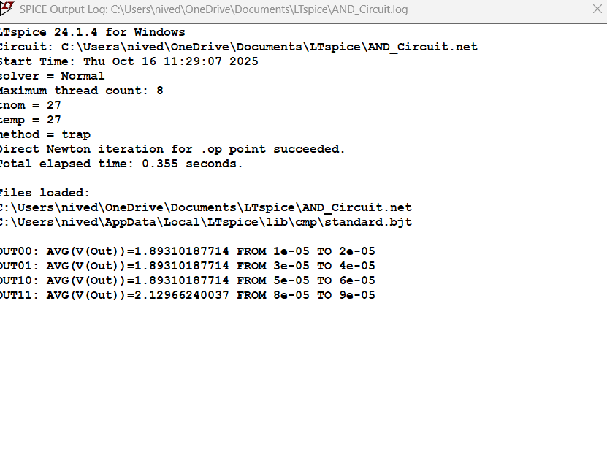

NAND Gate using BJT
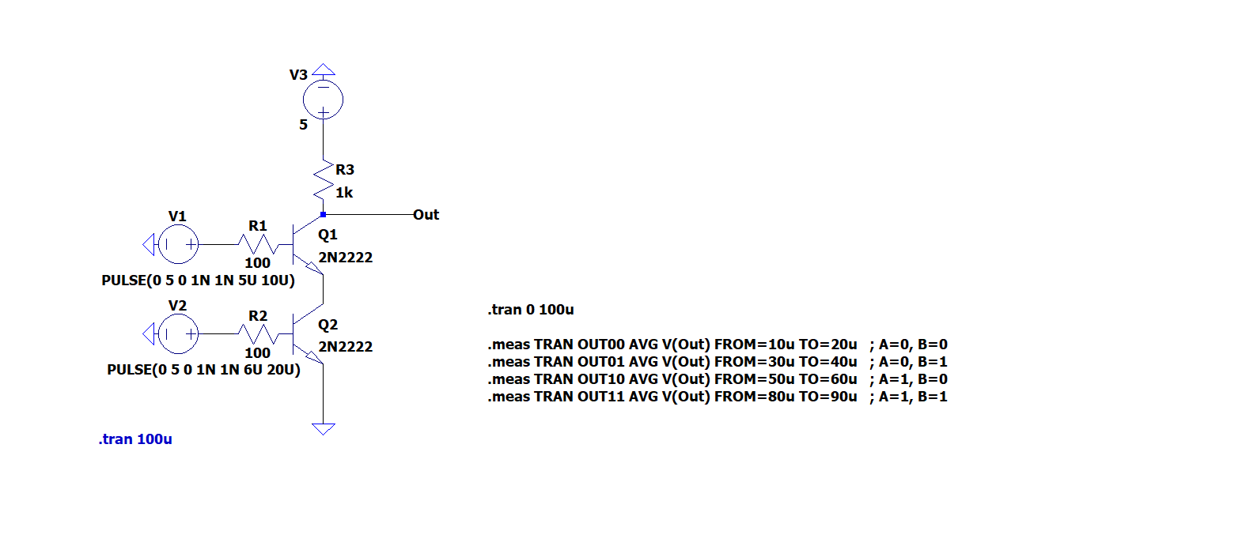

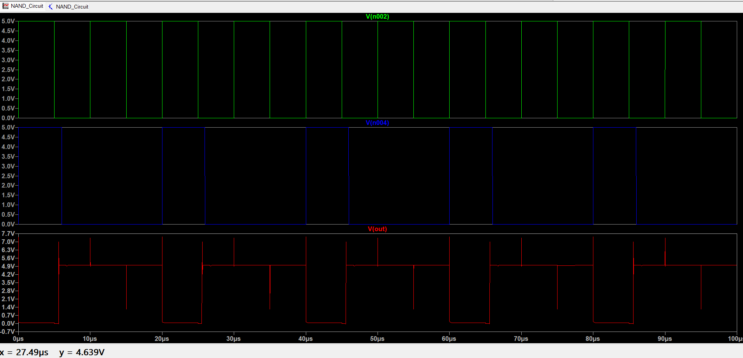

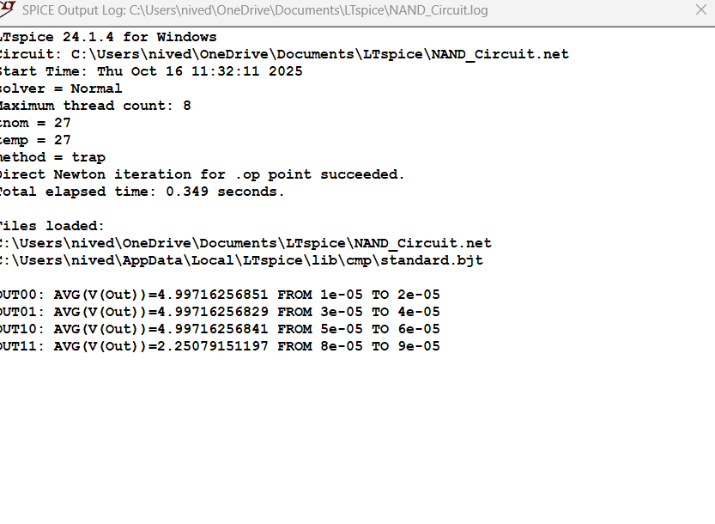
NOR Gate using BJT

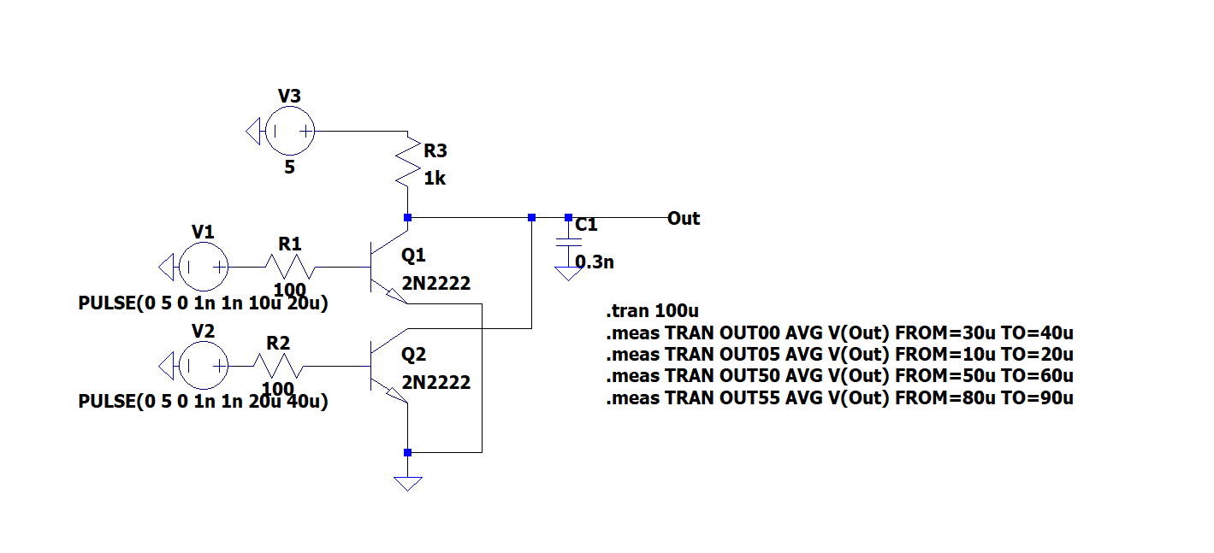

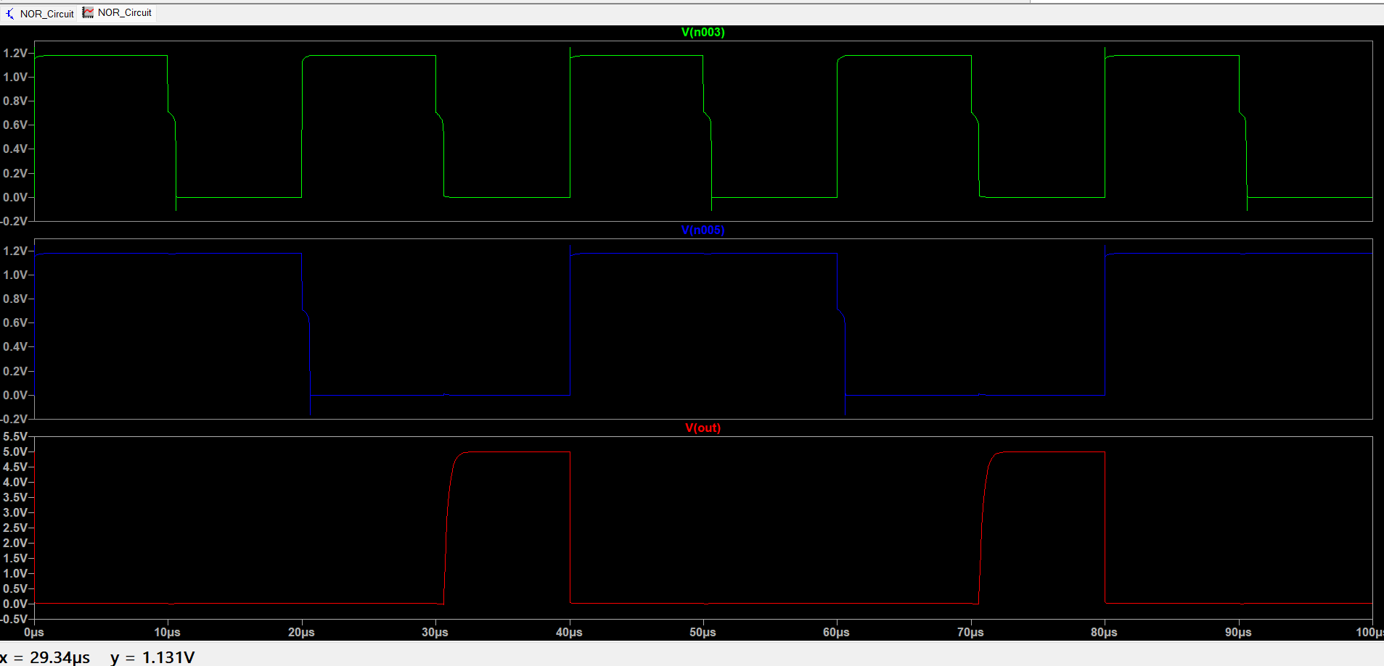

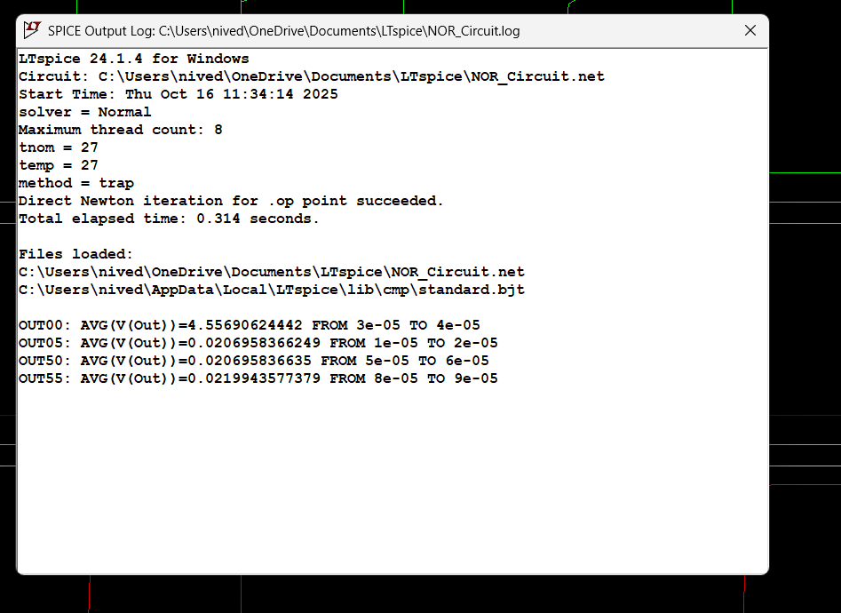
Conclusion :
The design and simulation of BJT-based NAND, NOR, and AND gates were successfully carried out using LTspice. The theoretical operation of each gate was confirmed through simulation, with outputs matching the expected truth tables. The study demonstrated that BJTs, when properly biased and operated as switches, can realize universal logic functions. These configurations represent the foundation of TTL logic families used in early digital systems. The experiment effectively bridges the gap between analog transistor operation and digital logic implementation, highlighting the versatility of BJTs in digital electronics.

References :
  - Neamen, D. A. (2010). Semiconductor Physics and Devices: Basic Principles. (Referenced for diode theory and rectification principles).
  - Neamen D. A. (2007). Electronic Circuit Analysis and Design
  - Online resource or manual used for LTSpice simulation techniques.

